Supporting your child with reading at home
- Echo reading – prosody Repeated reading
- Focus on small chunks rather than speeding through many pages Vocabulary and Inference based questions
- Being a role model and making reading a priority around the home Signing your child’s reading record
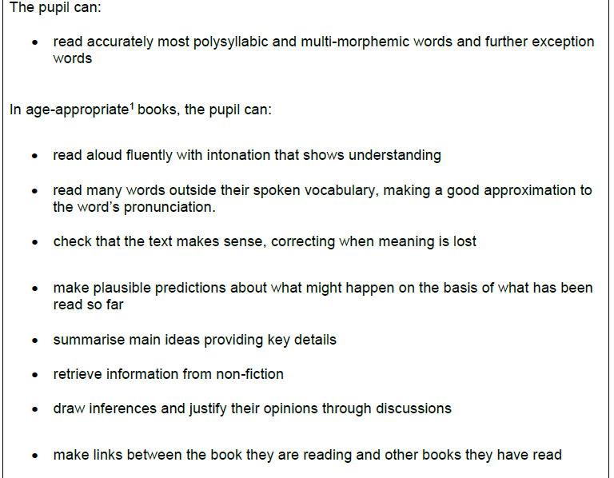
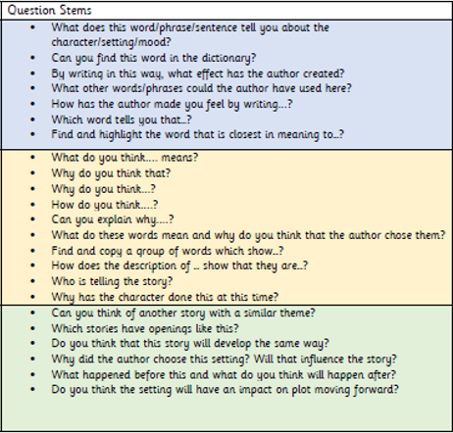
End of year outcomes

